

Tribhuvan University

Faculty of Humanities and Social Science

Travel Management System

A PROJECT REPORT

**Submitted To**

Department of Computer Application

Shahid Smarak College

*In partial fulfillment of the requirements of the Bachelors in Computer Application*

**Submitted by: -**

Amir Maharjan (26202002)

Saroj Maharjan (26202010)

January 2024



Tribhuvan University

Faculty of Humanities and Social Science

Shahid Smarak College

Supervisor’s Recommendation

I hereby recommend that this project prepared under my supervision by **Amir Maharjan** and **Saroj Maharjan** entitled **“Travel Management System”** in partial fulfillment of the requirements for the degree of Bachelor of computer Application is recommended for the final evaluation.

__________________

**Hari Lal Chalise**

SUPERVISOR

Shahid Smarak College

Kirtipur, Nayabazar



Tribhuvan University

Faculty of Humanities and Social Science

Shahid Smarak College

LETTER OF APPROVAL

This is to certify that this project prepared by **Amir Maharjan** and **Saroj Maharjan** entitled **“Travel Management System”** in partial fulfillment of the requirements for the degree of Bachelor in Computer Application has been evaluated. In our opinion it is satisfactory in the scope and quality as a project for the required degree.

|  |  |
| --- | --- |
| ­________________________  Hari Lal Chalise  Supervisor  Shahid Smarak College  Kirtipur, Nayabazar | ­_______________________  Mr Sanjay Jnawali  Coordinator  Shahid Smarak College  Kirtipur, Nayabazar |
| _________________________  Internal Examiner | ________________________  External Examiner |

**Acknowledgement**

We extend my heartfelt gratitude to the supervisor Hari Lal Chalise who played a pivotal role in the successful completion of the Travel Management System Project. His unwavering support and contributions have been instrumental in bringing this project to fruition.

We are deeply thankful to my project supervisor for his guidance, mentorship and invaluable insights throughout the project’s lifecycle. His expertise has been a guiding light that shaped the project’s direction. We also want to acknowledgement our families, whose unwavering support, understanding, patience were the pillars sustained throughout this project’s journey.

Lastly, this project has been collaborative effort, and we are proudly grateful to everyone who contributed in any capacity. The knowledge gained and lessons learned during this project will guide us in our future.

**Abstract**

The goal of the travel management system is to offer a complete solution for improving and expediting the booking and planning of travel. Organizing travel plans effectively is crucial for both people and companies. With the help of this project, customers will be able to easily plan, book, and manage their travel schedules on an intuitive web-based platform. The website provides a number of features designed to satisfy the various demands of visitors. Consumers have access to pricing, availability, and review searches. The Travel Management System's capacity to plan itineraries is one of its best features. By choosing locations and activities, users can design custom itineraries. Both frontend and backend technologies are used in the project's execution. Modern web technologies like HTML5, CSS3, and JavaScript are used in the frontend development process to ensure a visually appealing and responsive user experience. The backend uses databases and server-side scripting languages to handle user data, reservation details, and system logic.

**Keywords: Travel Management, Travel, Itinerary**

**Table of Contents**

Chapter 1: Introduction 1

1.1 Introduction of Proposed project 1

1.2 Problem Statement 1

1.3 Objectives 1

1.4 Scope and Limitation 1

1.5 Report Organization 2

Chapter 2 Background study and Literature Review 3

2.1 Background study 3

2.2 Literature review 3

Chapter 3: System Analysis and Design 5

3.1 System Analysis 5

3.1.1 Requirement Analysis 5

3.1.2 Feasibility Analysis 6

3.1.3 Data-Modeling (ER Diagram) 8

3.1.4 Process Modeling (DFD) 9

3.2 System Design 11

3.2.1 Architectural Design 11

3.2.2 Database Schema Design 12

3.2.3 Interface Design (UI interface / interface structure diagrams) 13

3.2.4 Physical DFD 17

Chapter 4: Implementation & Testing 18

4.1 Implementation 18

4.1.1 Tools used 18

4.1.2 Implementation details of modules 20

4.2 Testing 24

4.2.1 Test case for unit testing 24

4.2.2 Test case for system testing 26

Chapter 5: Conclusion & Future Recommendation 27

5.1 Lesson Learnt / Outcome 27

5.2 Conclusion 27

5.3 Future Recommendation 27

References 29

**List of Figures**

Figure 1: Gnatt chart 7

Figure 2: ER Diagram 8

Figure 3: DFD Level 0 9

Figure 4: DFD Level 1 9

Figure 5: DFD Level 2 10

Figure 6: Architectural Design 11

Figure 7: Database Schema 12

Figure 8: Header, Banner, Category Collection 13

Figure 9: About Us, Featured Package 14

Figure 10: Dates & Availability, Testimonials 15

Figure 11: Reviews, Blogs, Footer 16

Figure 12: Physical DFD Level 0 17

Figure 13: Physical DFD Level 1 17

Figure 14: Homepage 32

Figure 15: Single 35

Figure 16: Booking 36

Figure 17: Archive 37

**List of Tables**

Table 1: Login Test Case for User 24

Table 2: Registration Test Case for User 25

Table 3: Booking Test Case for User 25

List of Abbreviation

Adobe XD - Adobe Experience Design

AJAX - Asynchronous JavaScript and XM

CASE - Computer Aided Software Engineering

CSS - Cascading Style Sheet

DFD - Data Flow Diagram

DOM - Document Object Model

ER - Entity Relationship

HTML - Hyper Text Markup Language

MySQL - My Structured Query Language

PHP - HyperText Preprocessor

UI - User Interface

UML - Unified Modeling Language

XML - Extensible Markup Language

# 

# Chapter 1: Introduction

## **1.1 Introduction of Proposed project**

In an era defined by rapid globalization and the ever-expanding horizons of the digital age, the need for efficient and seamless travel management has become paramount. It is a software solution that helps organizations to manage and streamline their travel-related activities. It typically includes features such as booking and reservations, expense management, itinerary planning, and reporting. It can efficiently handle employee travel, control costs and ensure compliance with travel policies. The process of planning, booking and managing travel arrangements can be both complex and time consuming. It is in response to this challenge that we propose the development of a comprehensive “Travel Management System” that will plan, book and manage all travel arrangements with a single click of a button. While also exploring new travel destinations listed in the website.

## **1.2 Problem Statement**

Travelers have a hard time coming to a decision. They have to overcome many hurdles.

* Users cannot find best and affordable trips.
* They would have to manually visit the office.
* Cannot keep track of the users while in trip.

## **1.3 Objectives**

* To create a system that helps to choose the best and affordable trip.
* To view images of the destinations.
* To let new travelers read reviews from previous travelers.

## **1.4 Scope and Limitation**

**Scope**

* People with minimum knowledge about website can also use this website.
* Can become a community for travelers.
* User-friendly interface for booking.

**Limitation**

* Relies on internet connectivity for real-time tracking and updates.
* Initial implementation and training may require time and resources.

## **1.5 Report Organization**

This report contains five chapters including this chapter. Chapter two defines and describes Background Study and Overview of related existing systems and their pros and cons. Chapter three presents the System Analysis and Design including Requirement Analysis and Feasibility Analysis. Chapter four presents the Implementation, Testing and debugging are explained. In Chapter five, Conclusion, Limitations and Future Enhancement are briefly explained.

# Chapter 2 Background study and Literature Review

## **2.1 Background study**

This project is rooted (unlikely to be easily changed) in the dynamic and evolving travel industry. With the arrival of digital technology, travelers gradually rely on online platforms to plan and manage their trips and accommodations to exploring destinations and activities. This project seeks to address the growing demand for a comprehensive and user-friendly online platform that streamlines travel planning, enhances user experiences, and integrates various travel services seamlessly.

During the research phase of the project, we came across many websites that we could take as references. Daraz, a well-established e-commerce business was one of them. It’s a great platform to buy products from. It is constantly giving out discount coupons and amazing offers. We can also order products as a guest. But the biggest drawback of it, is that the UI is not very good and is very hard to navigate throughout the system.

Tripadvisor is one of the best travel websites out there. It provides reviews and evaluation of other people on destinations, trips, housing, etc. The major drawbacks are the bad UI design and the website looks like a blog website more than a travel website.

## **2.2 Literature review**

We looked into and examined a few relevant websites, papers, blogs, manuals, and applications for this project. We learn from the research that there aren't many websites or web-based applications dedicated to trip management.

In reference to [1], system was developed by Daraz Group and is the most used e-commerce business in Nepal. The most astonishing feature of Daraz is that it lets the user buy products without actually logging into the system. The users can buy products as a guest. Order placement feature is also equally impressive.

In reference to [2] & [3], system was developed by Nepal Everest Base Camp Trekking Company and Nepal Trekking Experts Pvt Ltd. Both of them showcase the best itinerary. Itinerary is a travel document recording a route or journey. It is very much similar to our own system. It has kept its itinerary simple and straight to point so that anyone can understand the journey.

In reference to [4], system was developed by Tripadvisor LLC & through its flagship Tripadvisor brand, Tripadvisor's travel research platform gathers member evaluations and comments about restaurants, activities, travel destinations, housing (including hotels, B&Bs, speciality lodging, and vacation rentals), and lodging.

In reference to [5], system was developed by ShineCommerce & is a WordPress website that most exemplifies what makes a good travel website. It need to be easy to use and straightforward. It also features a theme builder idea using the Elementor plugin, it offers a great deal of versatility in website creation.

In reference to

[6] & [7], systems were developed by Navan and GBT Travel Services UK Limited respectively & are both websites that offers travel and expense management. allows users to easily book, view, and manage business travel and expenses. [6] main principles are that software should: Enable human connections. One of [7] reviews: "Dependable tool to book travel, good support generally and in emergencies."

# Chapter 3: System Analysis and Design

## **3.1 System Analysis**

"System analysis" is the process of breaking down a system to improve it using better procedures and techniques. This process involves planning a new system to either improve or replace an existing system. Thus, it is the process of gathering and analyzing data, recognizing problems, and applying the data to provide feedback on system modifications.

When conducting a system analysis, the following objectives are kept in mind:

* Perform economic and technical analysis.
* Assign responsibilities to the database, hardware, software, and other parts of the system.

### **3.1.1 Requirement Analysis**

To ascertain the requirements and expectations of a new product, a technique known as requirements analysis or requirements engineering is utilized. It entails regular communication with the product's stakeholders and end users to clarify expectations, settle disputes, and record all essential requirements.

**i*.* Functional Requirement**

Functional requirements are requirement that make up our entire website. For example: a registration form, when a user fills it, the data that is submitted has to be stored in the database in a secure manner.

The system provides the following functionalities:

* Add to favorites
* User request to cancel their booking
* Light mode / Dark mode
* Attractive user interface
* Detailed pricing and plans of trips
* User can search for a trip

#### **ii. Non-Functional Requirement**

* **Reliability**

System will run 24/7. The data that is submitted won’t be made public or lost when the user logs in next time.

* **Security**

Personal data and information of the user will be stored in a secure manner so that these data and information won’t be hacked or misused.

* **Availability**

The system can be accessed by anyone, anytime and anywhere. What a user’s needs to access the system is a smartphone or a computer or a laptop and a internet connection, that is all.

* **Performance**

Every system needs to perform well in order to be liked by the users. The system is fast, interactive and is easy to use.

### **3.1.2 Feasibility Analysis**

Feasibility means to check if a proposed project or system can be done conveniently or not. A feasibility study is carried out to determine whether the project should (proceed) be done or not. The feasibility of a project is determined by the following: -

#### **i. Technical**

#### Technically speaking, there are no obstacles because all that is needed for the development stage is a functional computer and a reliable internet connection.

#### **ii. Operational**

There are no operational difficulties as well. To operate this system, all it needs is good database connection and a good host.

#### **iii. Economic**

Overall budget can be affected a little bit because of the purchase of database and a host.

#### **iv. Schedule**

Probably the most important aspect in feasibility study. If a project cannot be completed in time, the project should not even be in consideration. It should be rejected immediately.

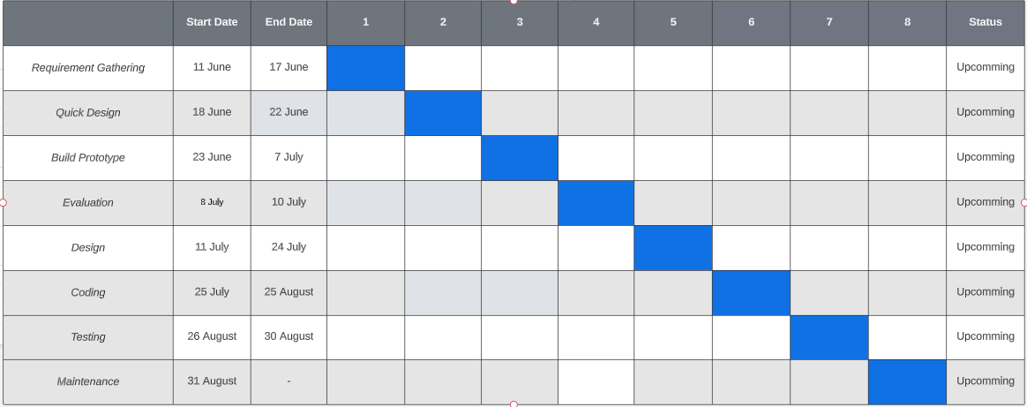

**Figure 1: Gnatt chart**

### **3.1.3 Data-Modeling (ER Diagram)**

A data model is a mechanism that provides abstraction for database application. Data models define how data is connected to each other and how they are processed and stored in a system. ER (Entity Relationship) diagram is a database structure that show the relationship between entity and their attributes connect with each other via primary key and foreign key.

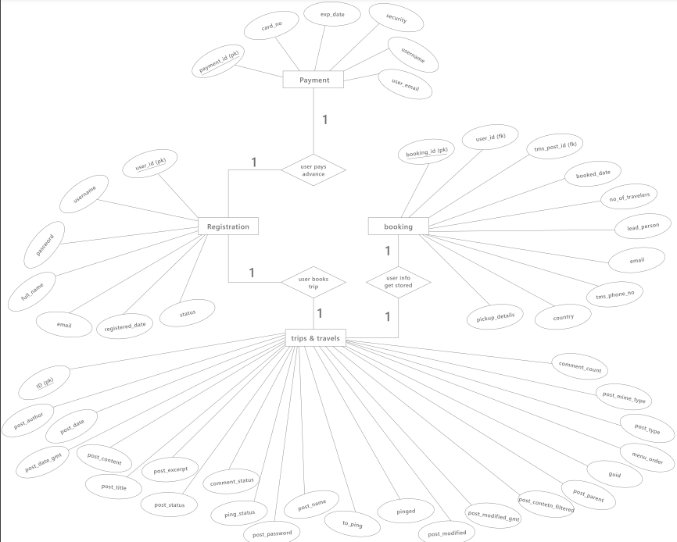

**Figure 2: ER Diagram**

### **3.1.4 Process Modeling (DFD)**

Data Flow Diagram (DFD) is a graphical representation of how the data flows in the proposed or an already existing system. The DFD is also known as context diagram or bubble chart. Its main purpose is to help understand how the data flows in the system. The figure below is a basic data flow diagram of “Travel Management System”.

DFD level 0 is a graphical representation of the system without much detail. It just gives a basic overview of how the data flows in the proposed or an already existing system. Below is a DFD level 0 figure:

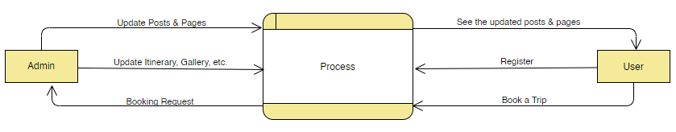

**Figure 3: DFD Level 0**

DFD level 1 is another graphical representation of the system that has more detail of how the data flows in the system. It has more details than the DFD level 0. A DFD level 1 is given below:

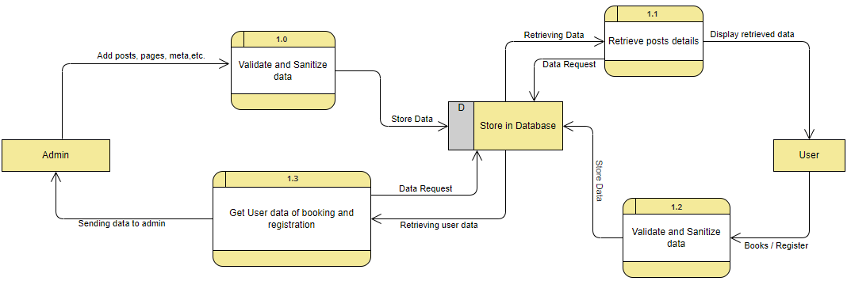

**Figure 4: DFD Level 1**

DFD level 3 has the more details of how the data flows in the system than any other level. It tries to display as much detail of data flows as possible. A figure of DFD level 3 is given below:

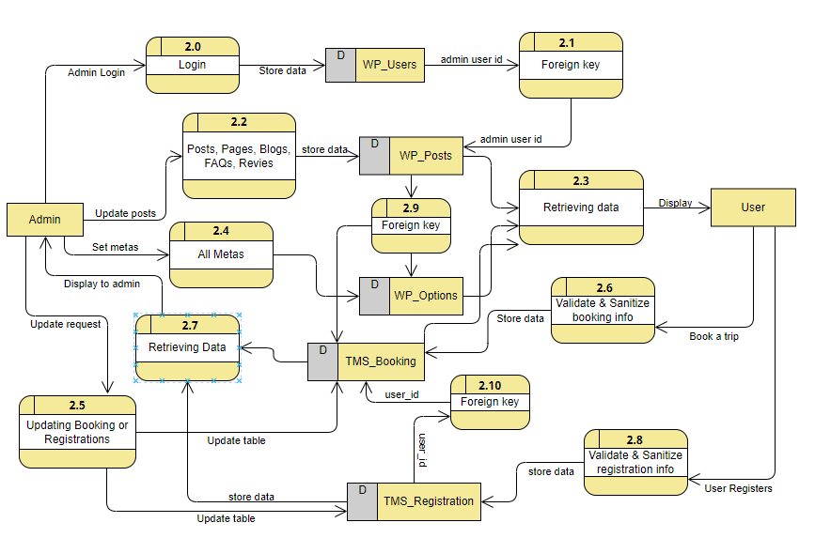

**Figure 5: DFD Level 2**

## **3.2 System Design**

The process of meeting the end-user requirements by designing the architecture, components and interfaces for the system is called system design. The system must be designed in such a way that it meets all of the end-user’s requirements.

### **3.2.1 Architectural Design**

The purpose of this phase is to design how the users will see the system, how the system deals with user inputs and how the data gets stored in the database. All these things are planned and carried out in detail without missing out on anyone of these things.

**Presentation login:** how the users will see the system.

**Business logic:** how the user’s inputs will be handled.

**Database driver:** how the user’s inputs are stored in the database.

The architecture of the application is shown in the figure below.

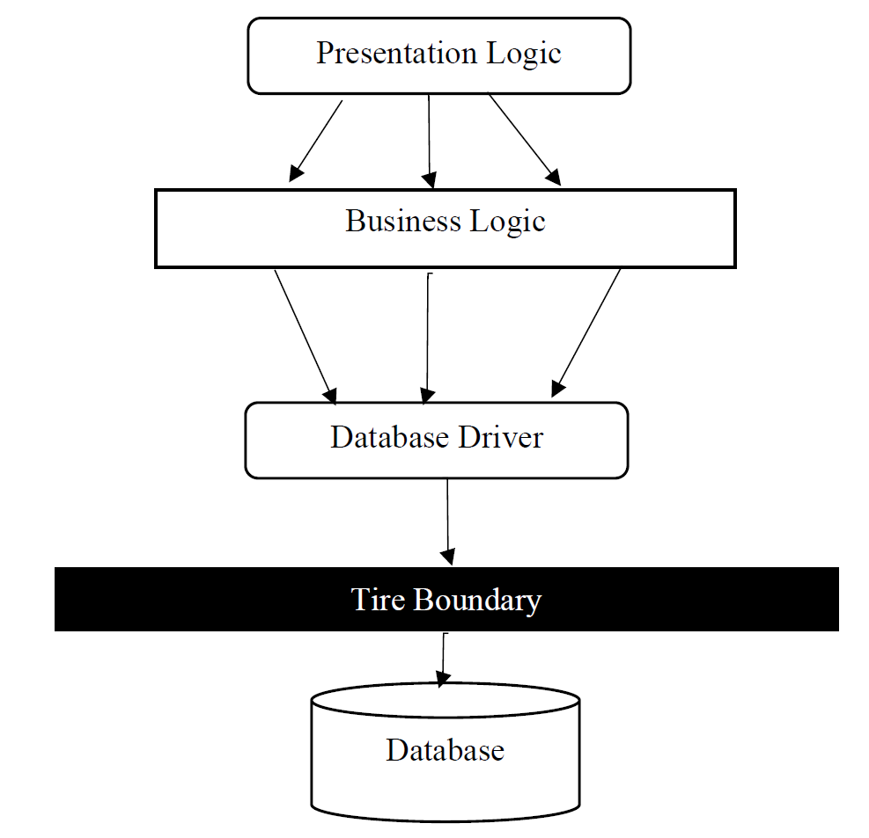

**Figure 6: Architectural Design**

### **3.2.2 Database Schema Design**

According to dictionaries, schemas are a representation of a plan or theory in the form of an outline or model. Database schema is the skeleton structure that represents the logical view of the entire database. It shows the relationship between different tables and its attributes. Two tables are linked with each other by the use of primary key and foreign key. It is designed by database designers.

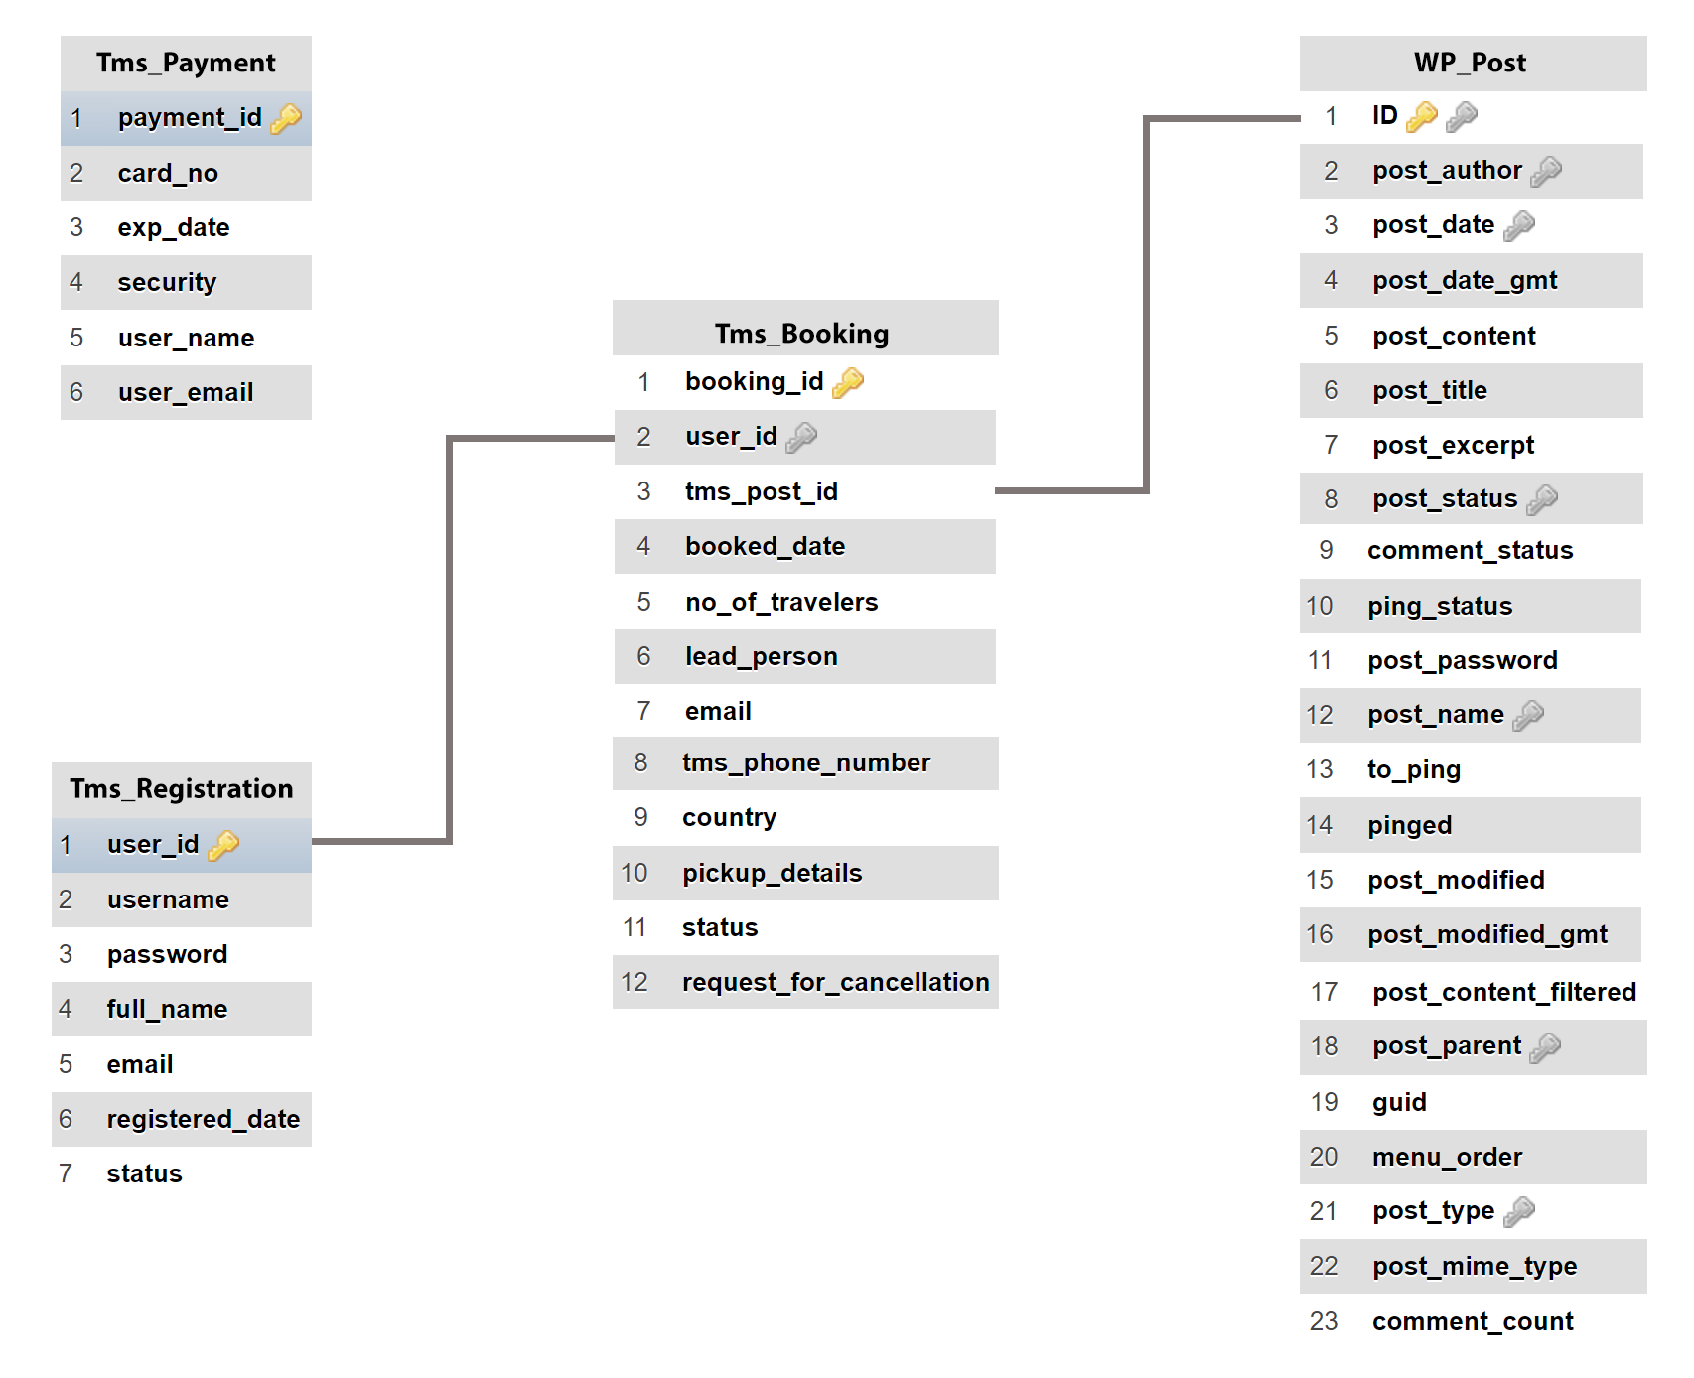

**Figure 7: Database Schema**

### **3.2.3 Interface Design (UI interface / interface structure diagrams)**

Photoshop and Adobe XD have been used in the design of the application's or system's UI. Both are user-interface tools for producing, modifying, and working with raster and vector pictures. The figures below represent some of the features of the system like theme mode, login system, registration system, review section, etc. 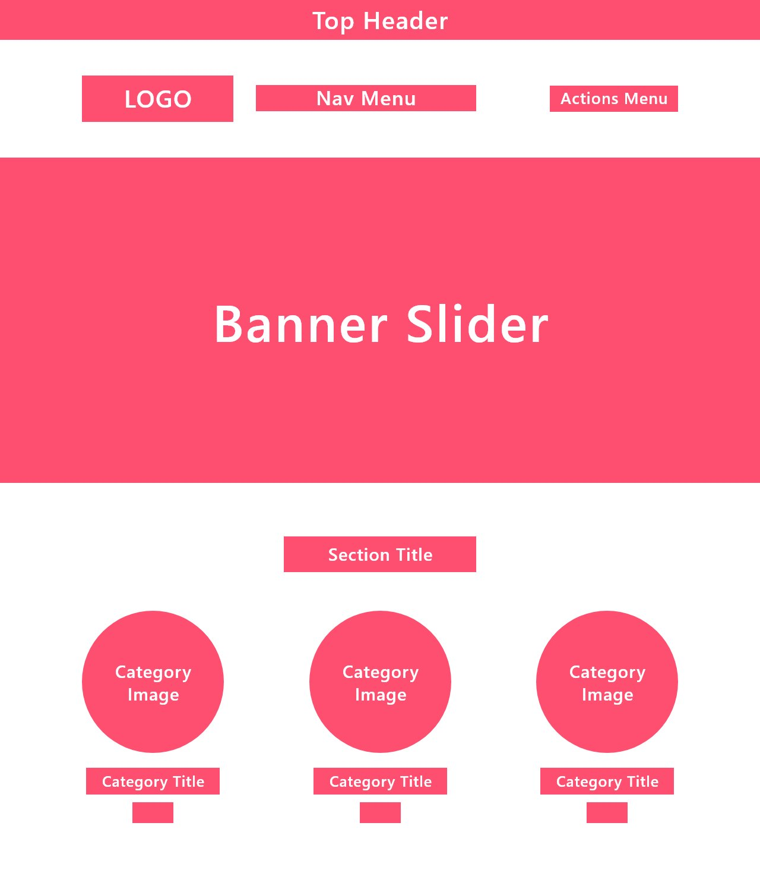

**Figure 8: Header, Banner, Category Collection**

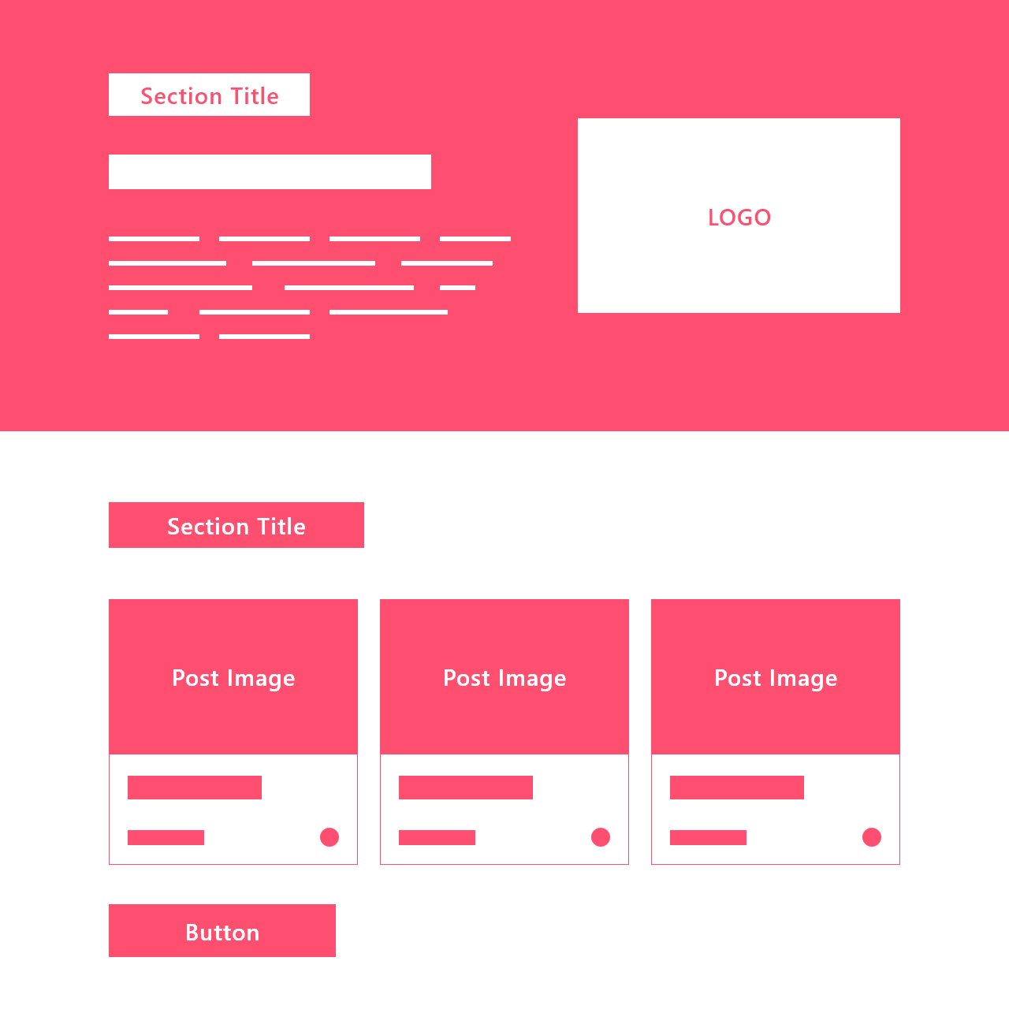

**Figure 9: About Us, Featured Package**

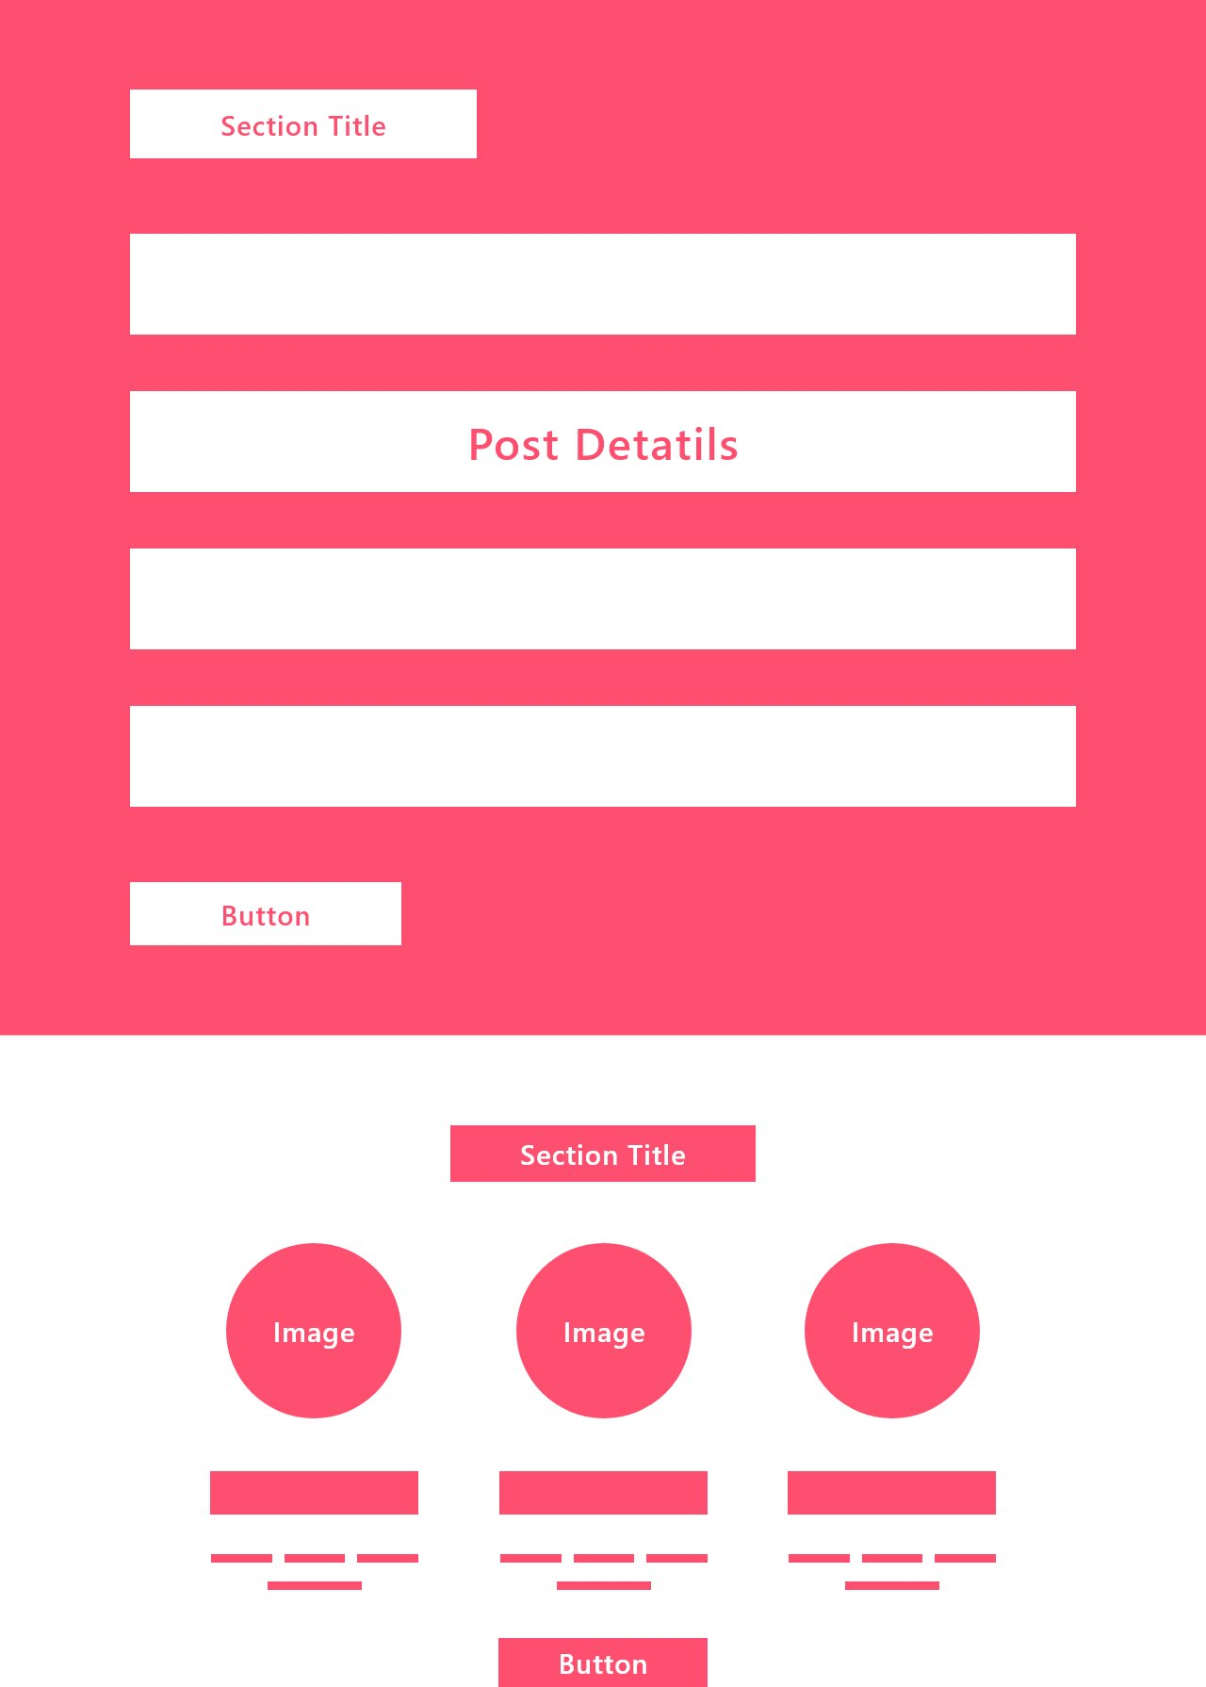

**Figure 10: Dates & Availability, Testimonials**

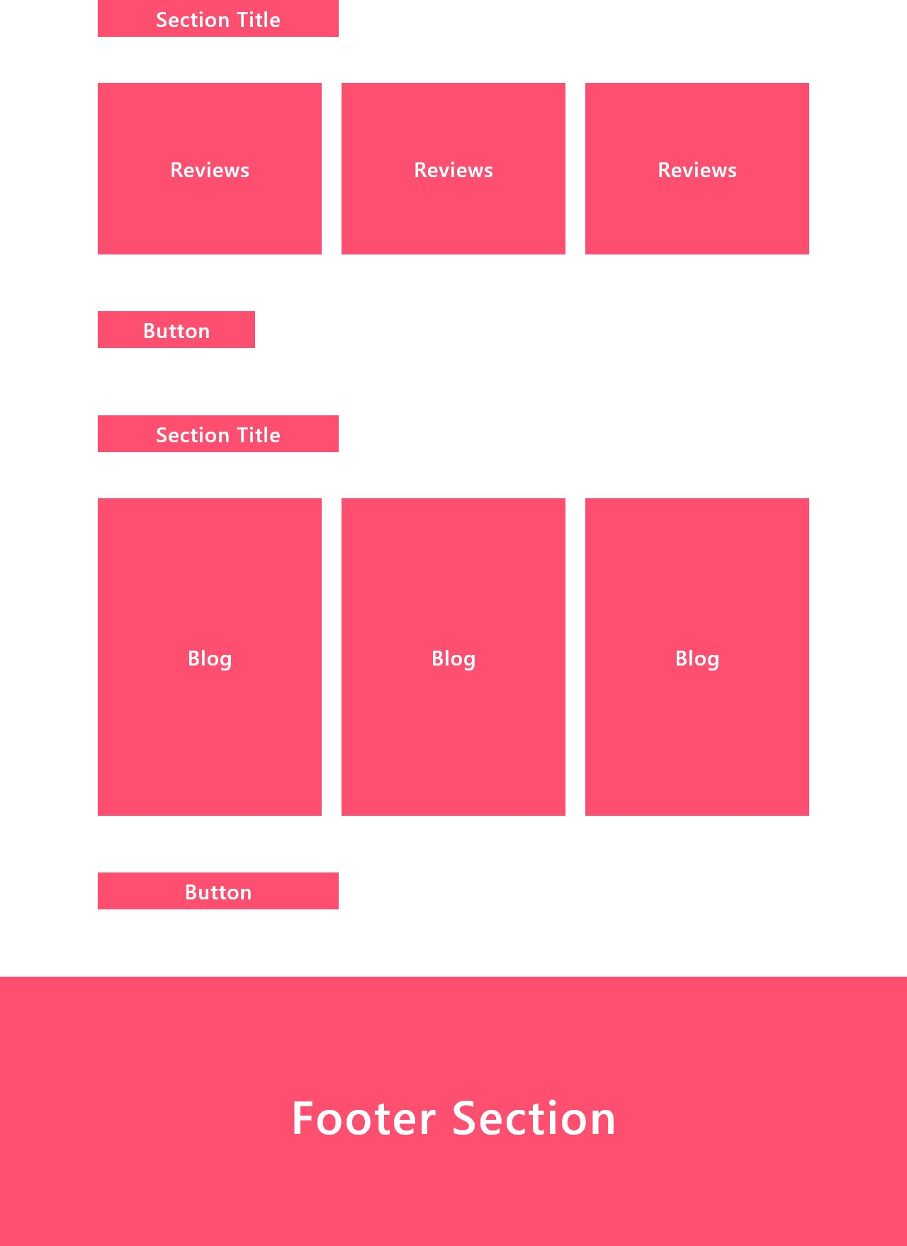

**Figure 11: Reviews, Blogs, Footer**

### **3.2.4 Physical DFD**

Physical DFD is similar to logical DFDs. The main difference between the two DFD types is physical DFD represents how the system is actually implemented where as the logical DFD represents a generic flow of data.

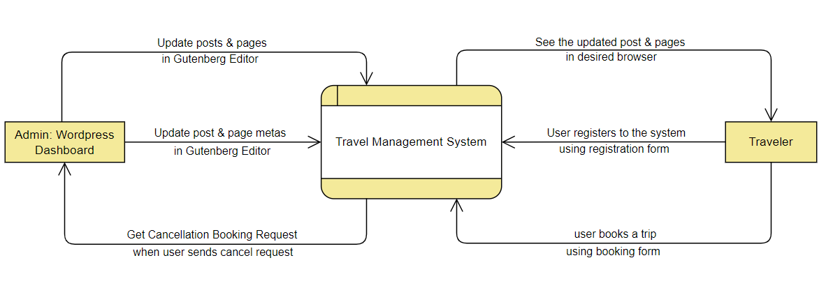

**Figure 12: Physical DFD Level 0**

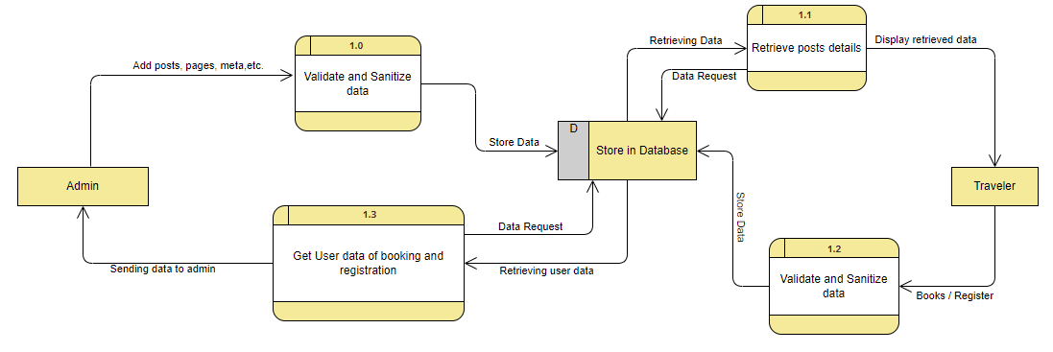**Figure 13: Physical DFD Level 1**

# Chapter 4: Implementation & Testing

## **4.1 Implementation**

Before collaborating with content writers and quality assurance specialists to produce thorough documentation, developers will conduct a final review of the newly implemented system. This means that the development team can now begin getting ready for the product launch.

During the deployment phase, the software development team is ready to collect and evaluate user feedback in order to better understand how their product is functioning and how to improve it in order to boost customer satisfaction.

### **4.1.1 Tools used**

This section describes about the tools used during this project. The tools used are categories into three groups.

**CASE Tools:** A product that helps to analyze, model and document business processes.

**Programming Languages:** The programming languages used in this project.

**Database Platforms:** Databases used in the project.

**Libraries used:** A list of JavaScript libraries used.

#### **4.1.1.1 CASE Tools**

* **Draw.io**

Diagrams.net also known as draw.io is a cross-platform graph drawing software developed in HTML5 and JavaScript. Its interface can be used to create diagrams such as flowcharts, wireframes, UML diagrams, organizational charts, and network diagrams. Parts of its source code are provided under the Apache 2 open-source license.

* **Lucidchart**

Lucidchart is a web-based diagramming application that allows users to visually collaborate on drawing, revising and sharing charts and diagrams, and improve processes, systems, and organizational structures. It is produced by Lucid Software Inc., based in Utah, United States and co-founded by Ben Dilts and Karl Sun.

#### **4.1.1.2 Programming Languages**

Programming languages is further divided into two categories frontend and backend which have different set rules and implementation.

#### **4.1.1.2.1 Frontend**

* **HTML**

The Hypertext Markup Language or HTML is the standard markup language for documents designed to be displayed in a web browser. It defines the meaning and structure of web content. It is used in every part of the project as it creates the DOM that makes a website.

* **CSS**

Cascading Style Sheets is a style sheet language used for describing the presentation of a document written in a markup language such as HTML or XML. CSS is a cornerstone technology of the World Wide Web, alongside HTML and JavaScript. CSS is responsible for designing the website.

* **jQuery**

A JavaScript library called jQuery was created to make HTML DOM tree traversal and manipulation, event handling, CSS animation, and Ajax easier. Seventy-seven percent of the 10 million most popular websites as of August 2022 use jQuery. To make the website more user-friendly, we have handled the general behaviors with jQuery rather than with pure JavaScript.

#### **4.1.1.2.2 Backend**

* **PHP**

PHP is an open-source general-purpose programming language that is extensively used, particularly for web development, and can be incorporated into HTML. PHP is an acronym for PHP Hypertext Preprocessor. The servers, databases, etc. are all communicated with via it. Along with ensuring that everything on the client-side functions, it is also in charge of organizing and storing data.

* **AJAX**

Ajax is a set of web development techniques that uses various web technologies on the client-side to create asynchronous web applications. With Ajax, web applications can send and retrieve data from a server asynchronously without interfering with the display and behavior of the existing page.

#### **4.1.1.3 Database Platforms**

* **phpMyAdmin**

phpMyAdmin is a free and open-source administration tool for MySQL and MariaDB. As a portable web application written primarily in PHP, it has become one of the most popular MySQL administration tools, especially for web hosting services. All the data of the website is stored in the database.

#### **4.1.1.4 Libraries used**

* **Slick Slider**: A JavaScript library specializing in slider / carousels.
* **jQuery Cookie**: A simple JavaScript Library that helps in creating cookies.
* **Magnific Popup**: A library that displays images in popups.

### **4.1.2 Implementation details of modules**

Following the completion of the planning phase, we go on to the implementation phase, when the entire system is broken down into modules in order to reduce effort and find any new faults or issues. The report cannot describe every element of the modules, but it will document the majority of them. Among the modules are a few of these:

* **Login**

if( $login_username && $login_password ) {

$from_tms_registration=function_to_use_in_login_form($login_username,$login_password;

if( $from_tms_registration ) {

$tms_registration_insert_query = $wpdb->update('tms_registration',['status'=>'online’],

['username' => $login_username ] );

if( $tms_registration_insert_query ) {

/* user is logged in */

}

* **Logout**

if($_SERVER['REQUEST_METHOD'] == 'POST'):

if(isset($_POST['tms_logout'])&&isset($_POST['login_user_id'])):

$logged_in_user_id = $_POST['login_user_id'];

$logout_query = $wpdb->update( 'tms_registration', [ 'status' => 'offline' ], [ 'user_id' => $logged_in_user_id ] );

if( ! $logout_query ) :

echo 'Failed to logout';

endif;

endif;

endif;

* **Booking**

if( $b_trip_date && $b_no_of_traveler && $b_first_name && $b_last_name && $b_username && $b_email_address && $b_phone_number && $b_country && $b_pickup_details ) :

global $wpdb;

$from_tms_registration = user_id_username_from_tms_registration();

if( ! empty( $from_tms_registration ) ) :

foreach( $from_tms_registration as $reg_key => $registration ) :

if( $b_username == $registration ) $reg_user_id = $reg_key;

endforeach;

$tms_booking_insert_args = [

'user_id' => $reg_user_id,

'booked_date' => $b_trip_date,

'no_of_travelers' => $b_no_of_traveler,

'lead_person' => $b_first_name .' '.$b_last_name,

'email' => $b_email_address,

'tms_phone_number' => $b_phone_number,

'country' => $b_country,

'pickup_details' => $b_pickup_details,

'tms_post_id' => $tms_post_id

];

if( in_array( $b_username, array_values( $from_tms_registration ) ) ) :

$tms_booking_insert_query = $wpdb->insert( 'tms_booking', $tms_booking_insert_args );

if( $tms_booking_insert_query ) :

/* Booked Successfully

* **Thememode**

var themeModeContainer = $('.theme-mode-action-wrap')

if( themeModeContainer.length > 0 ) {

themeModeContainer.on( 'click', '.theme-mode-element', function(){

var _this = $(this), bodyElement = _this.parents('body')

_this.hide().siblings().show()

bodyElement.toggleClass('dark-mode')

if( bodyElement.hasClass('dark-mode') ) {

bodyElement.removeClass('light-mode')

$.cookie('themeMode', 'dark-mode', { expires: 1, path: '/' })

} else {

bodyElement.addClass('light-mode')

$.cookie('themeMode', 'light-mode', { expires: 1, path: '/' })

}

})

}

* **Registration**

if( $first_name && $last_name && $address && $contact && $email && $reg_username && $reg_password ) :

$full_name = $first_name .' '. $last_name;

$registered_date = date( 'Y-m-d' );

$tms_registration_insert_args = [

'username' => $reg_username,

'password' => $reg_password,

'full_name' => $full_name,

'email' => $email,

'registered_date' => $registered_date

];

global $wpdb;

$from_tms_registration = user_id_username_from_tms_registration();

if( ! in_array( $reg_username, array_values( $from_tms_registration ) ) ):

$tms_registration_insert_query = $wpdb->insert( 'tms_registration', $tms_registration_insert_args );

if( $tms_registration_insert_query ):

/* Successfully registered */

* **Metabox**

Metas are information about the information. Process to create a metabox is written below.

**Step 1:** Simple html is written:

<p class="max-altitude" id="max-altitude">

<label for="max_altitude">

<?php echo esc_html__( 'Max Altitude: ', 'travel-management-system' ); ?>

</label>

<input type="text" name="max_altitude" id="max_altitude" value="<?php echo esc_attr( $max_altitude ); ?>">

</p>

**Step 2:** Updated in the database:

if( array_key_exists( 'max_altitude', $_POST ) ) update_post_meta( $post_id, 'max_altitude', $_POST['max_altitude'] );

**Step 3:** Retrived from the database:

$max_altitude = get_post_meta( $post->ID, 'max_altitude', true );

**Step 4:** Value retrived from the database is used in the value attribute of input tag

## **4.2 Testing**

Now that the system has been designed, examined, and put into operation, it is time to test it for flaws and faults. The testing step of the system development process is essential since it reduces errors and aids in system troubleshooting. Although there are many various kinds of tests that can be done, for the sake of this report, we will mostly concentrate on the system's functionality, performance, and security.

### **4.2.1 Test case for unit testing**

* **User Login Test Case**

**Table 1: Login Test Case for User**

|  |  |  |  |  |  |
| --- | --- | --- | --- | --- | --- |
| **ID** | **Test Case Description** | **Test data** | **Expected**  **Result** | **Actual Result** | **Pass / Fail** |
| 1 | Wrong username | Username:  test@1234  Password:  Amir12345 | Username does not exist | As expected | Pass |
| 2 | Wrong password | Username:  Amir12345  Password:  test@1234 | Password does not match | As expected | Pass |
| 3 | Valid username and password | Username:  Amir12345  Password:  Amir12345 | Login | As expected | Pass |

* **User Registration Test Case**

**Table 2: Registration Test Case for User**

|  |  |  |  |  |
| --- | --- | --- | --- | --- |
| **ID** | **Test Case Description** | **Expected**  **Result** | **Actual Result** | **Pass / Fail** |
| 1 | All form fields filled and valid | Successfully registered | As expected | Pass |
| 2 | Empty one or more form fields | Please fill all the required fields | As expected | Pass |
| 3 | Already used username | Username already in use | As expected | Pass |

* **User Booking Test Case**

**Table 3: Booking Test Case for User**

|  |  |  |  |  |
| --- | --- | --- | --- | --- |
| **ID** | **Test Case Description** | **Expected**  **Result** | **Actual Result** | **Pass / Fail** |
| 1 | All form fields filled and valid | Successfully Booked | As expected | Pass |
| 2 | Empty one or more form fields | Please fill all the required fields | As expected | Pass |
| 3 | Enter wrong username | Username does not exist. Please register first. | As expected | Pass |

### **4.2.2 Test case for system testing**

* Verify that the username is greater or equal to 8 characters or more.
* Verify that the password is stored in the database via md5 or password hashing.
* Verify that phone numbers are 10 characters long or not and are numeric or not.
* Verify that the emails are valid or not by filtering the emails
* Verify that for better UI interface and user satisfaction, form fields contain dropdowns, radio buttons, checkboxes, sliders, etc.
* Verify that on form submit data are stored in the database properly.
* Verify that the cookies are set on click.
* Verify that required form fields are filled.

# Chapter 5: Conclusion & Future Recommendation

## **5.1 Lesson Learnt / Outcome**

This project taught us many things on personal and professional level. On personal level, we learned to work in a team and communicate better with each other. On the professional side, we learned that there are many aspects to keep in consideration during the development of the project like accessibility (people with physical disability should also be able to use website), internationalization (website should be free of any language barriers), security, etc. In order to receive a positive response from the customer, a project needs to be finished by the specified timeframe. Communicate with users on a regular basis to learn about their needs and requirements.

## **5.2 Conclusion**

Our goal was to create a system that would enable users to plan trips whenever they wanted, from anywhere. The users can view various tours and travels, read about them, view their FAQs and reviews, see their price information, etc. These objectives have been met by the current application. We completely adhered to the requirements, but, when necessary, we extended some of the features. The foundation of the application and this project has been accomplished with the targets met. Building this web application has been tough and rewarding because I've learned a lot about PHP, jQuery, WordPress, and what it takes to create a completely functional website while working on the project. There have been difficulties, particularly with the backend and ensuring that application replies are predictable. The task was made simpler by thorough planning because it required thoughtful thought.

For this project, WordPress and PHP were used because to their widespread popularity and relative simplicity when compared to other scripting languages and content management systems. We can use and download it for free because it is open source. Additionally, it is platform independent.

## **5.3 Future Recommendation**

In order to enhance this website's mobility, usability, and user experience, the following can be added in the future. Although completing all of these will require more time, finances, research, and study, it is still highly achievable and doable.

* Making WordPress custom widget and adding them to our website
* Making use of WordPress customizer and making website even more dynamic
* Making a WordPress plugin to enrich website with even more features.
* Adding update user profile section
* Adding change password section
* Adding video playlist section
* Adding payment gateways
* Adding custom feedback and reviews section

# References

|  |  |
| --- | --- |
| [1] | Daraz, "Daraz," [Online]. Available: https://www.daraz.com.np/. |
| [2] | N. E. B. C. T. Company, "Nepal Everest Base Camp," [Online]. Available: https://www.nepaleverestbasecamp.com/. |
| [3] | N. T. Experts, "Nepal Trekking Experts," [Online]. Available: https://nepaltrekkingexperts.com/. |
| [4] | T. LLC, "Tripadvisor," [Online]. Available: https://www.tripadvisor.com/. |
| [5] | S. Commerce, "Traveler," [Online]. Available: https://modmixmap.travelerwp.com/. |
| [6] | Navan, "Navan," [Online]. Available: https://navan.com/. |
| [7] | Egancia, "AMEX GBT Egencia," [Online]. Available: https://www.egencia.co.uk/en. |

**Appendix**

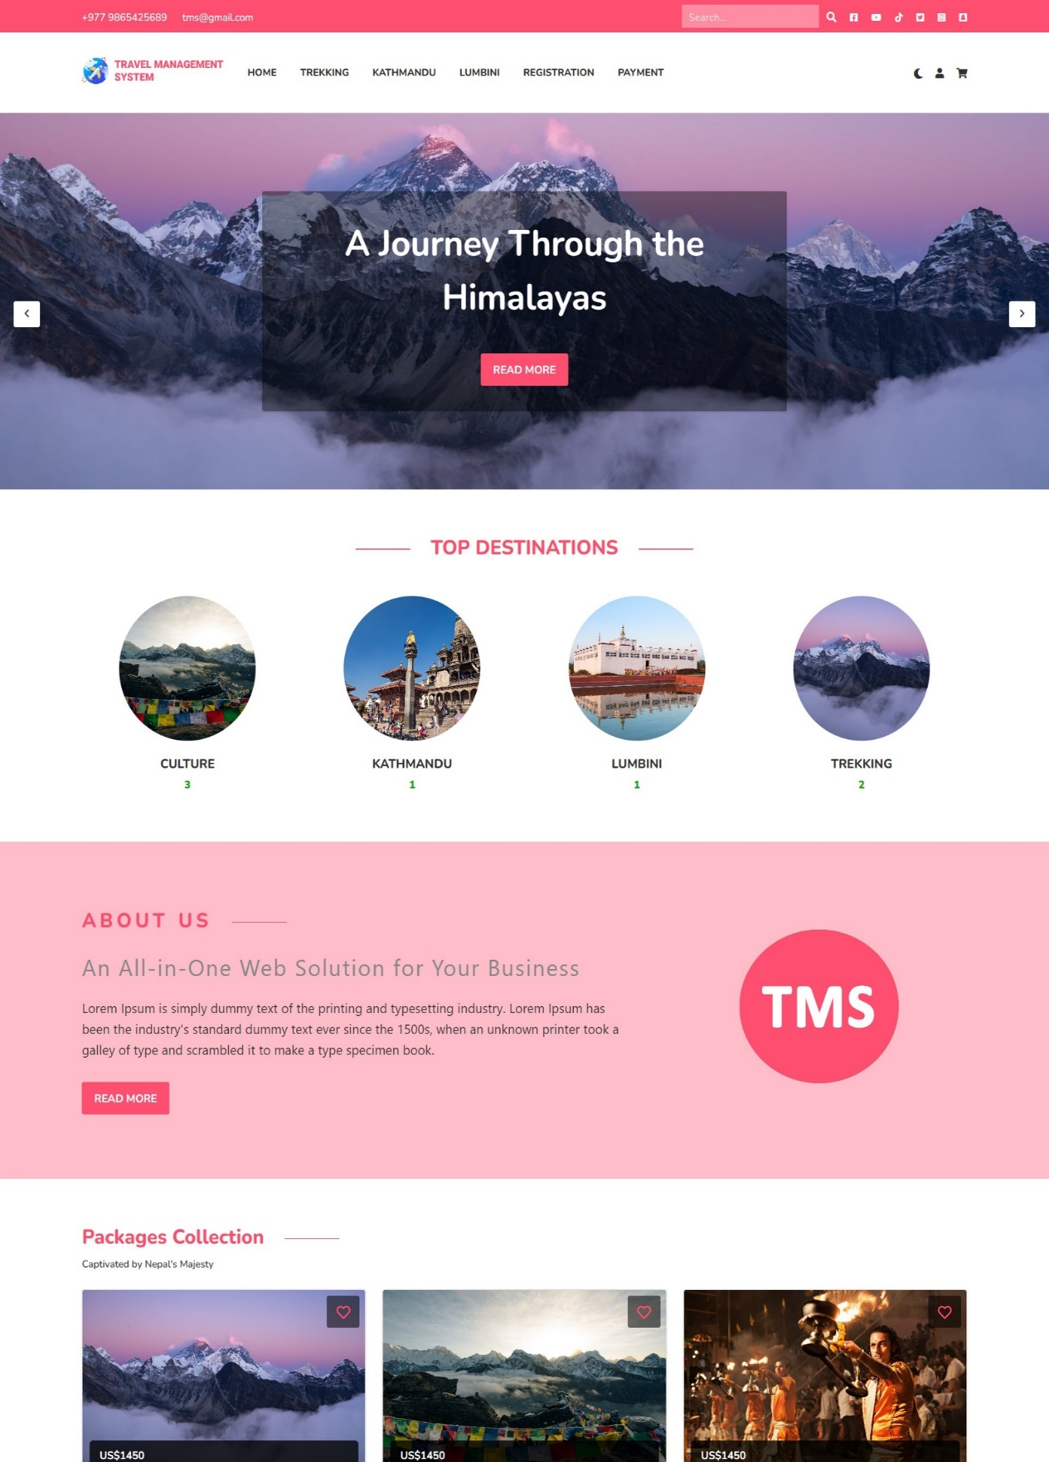

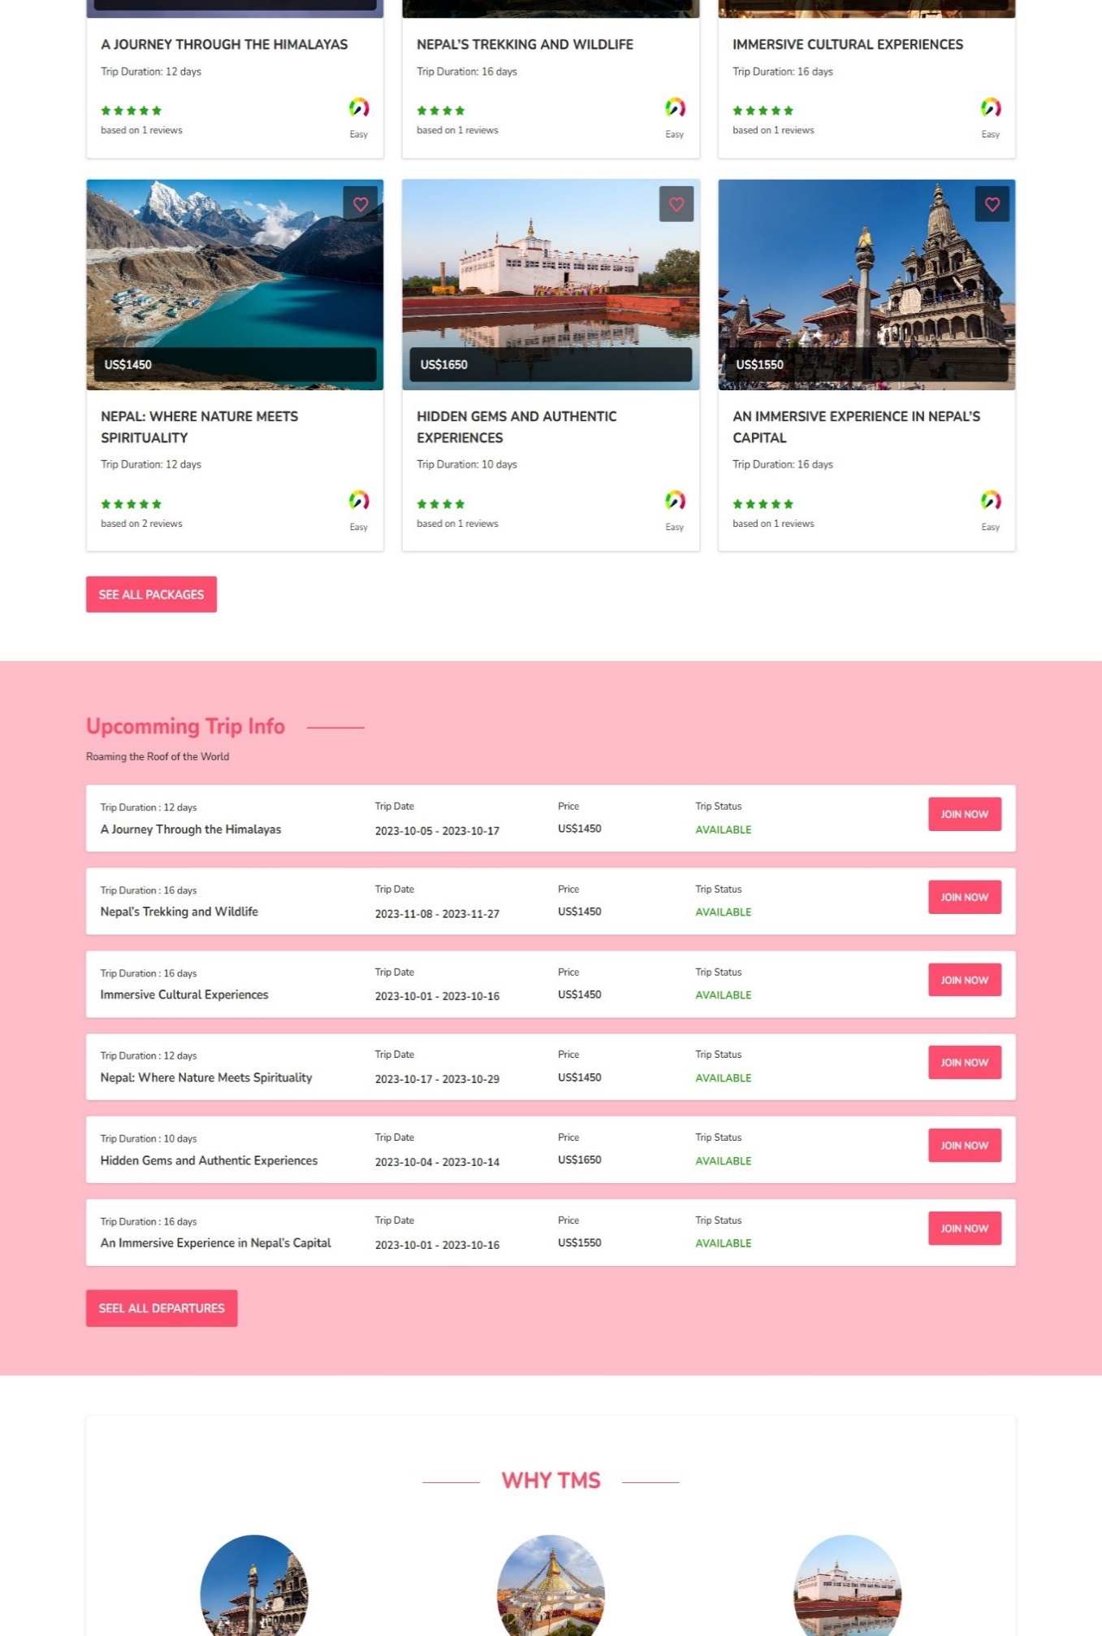

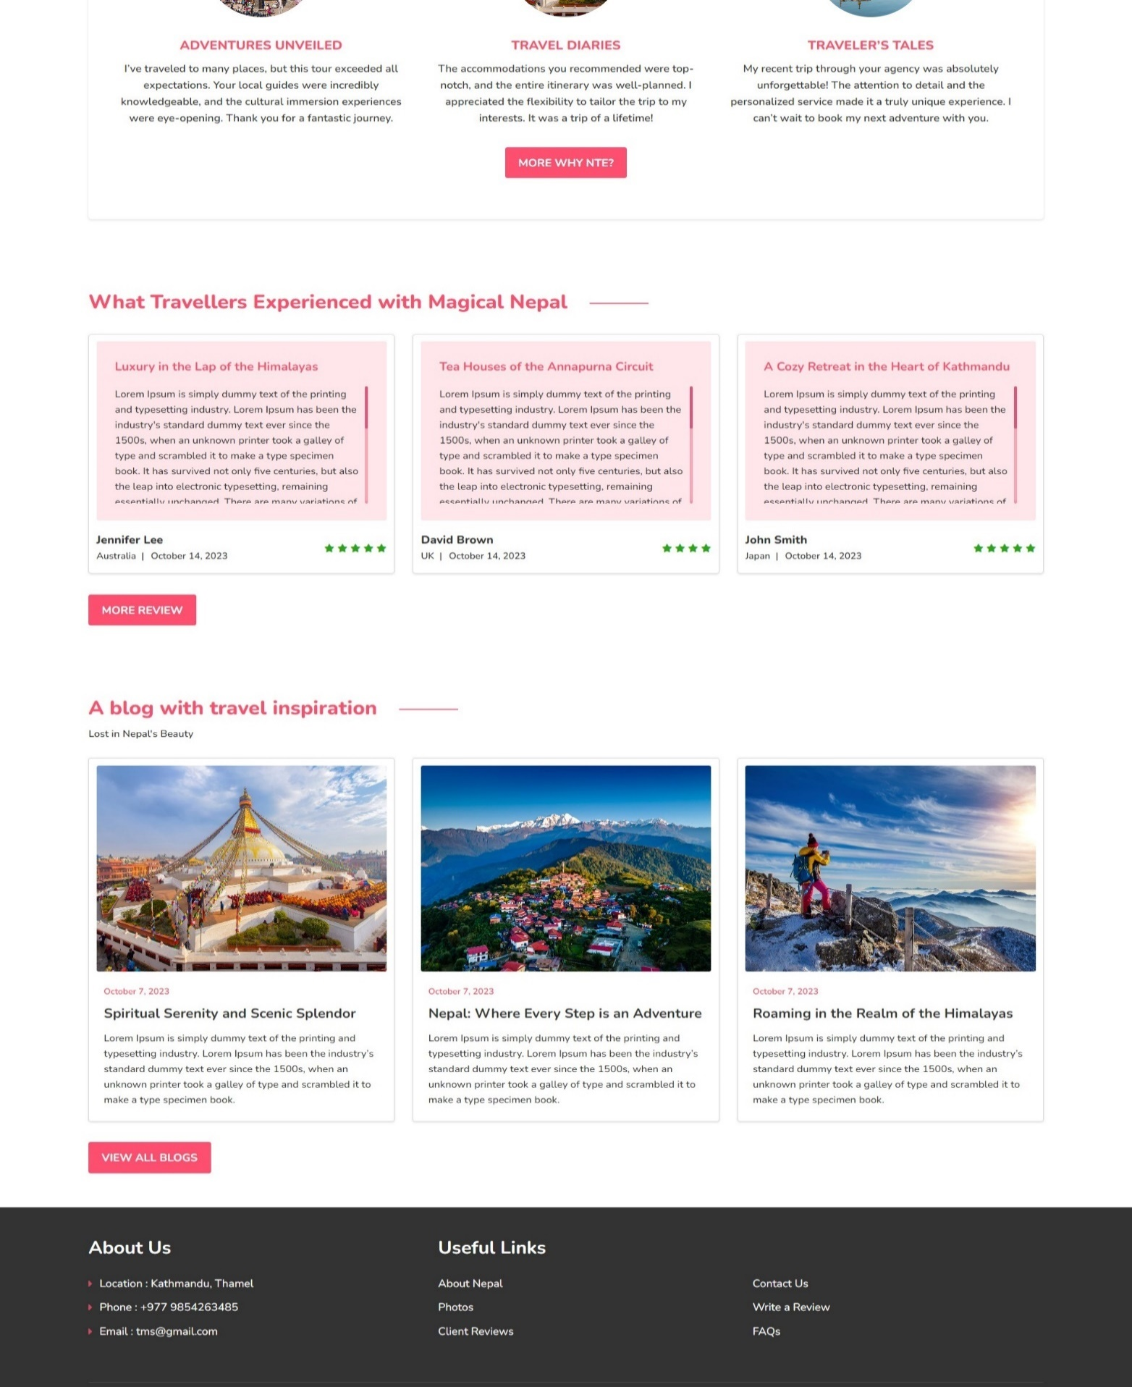 **Figure 14: Homepage**

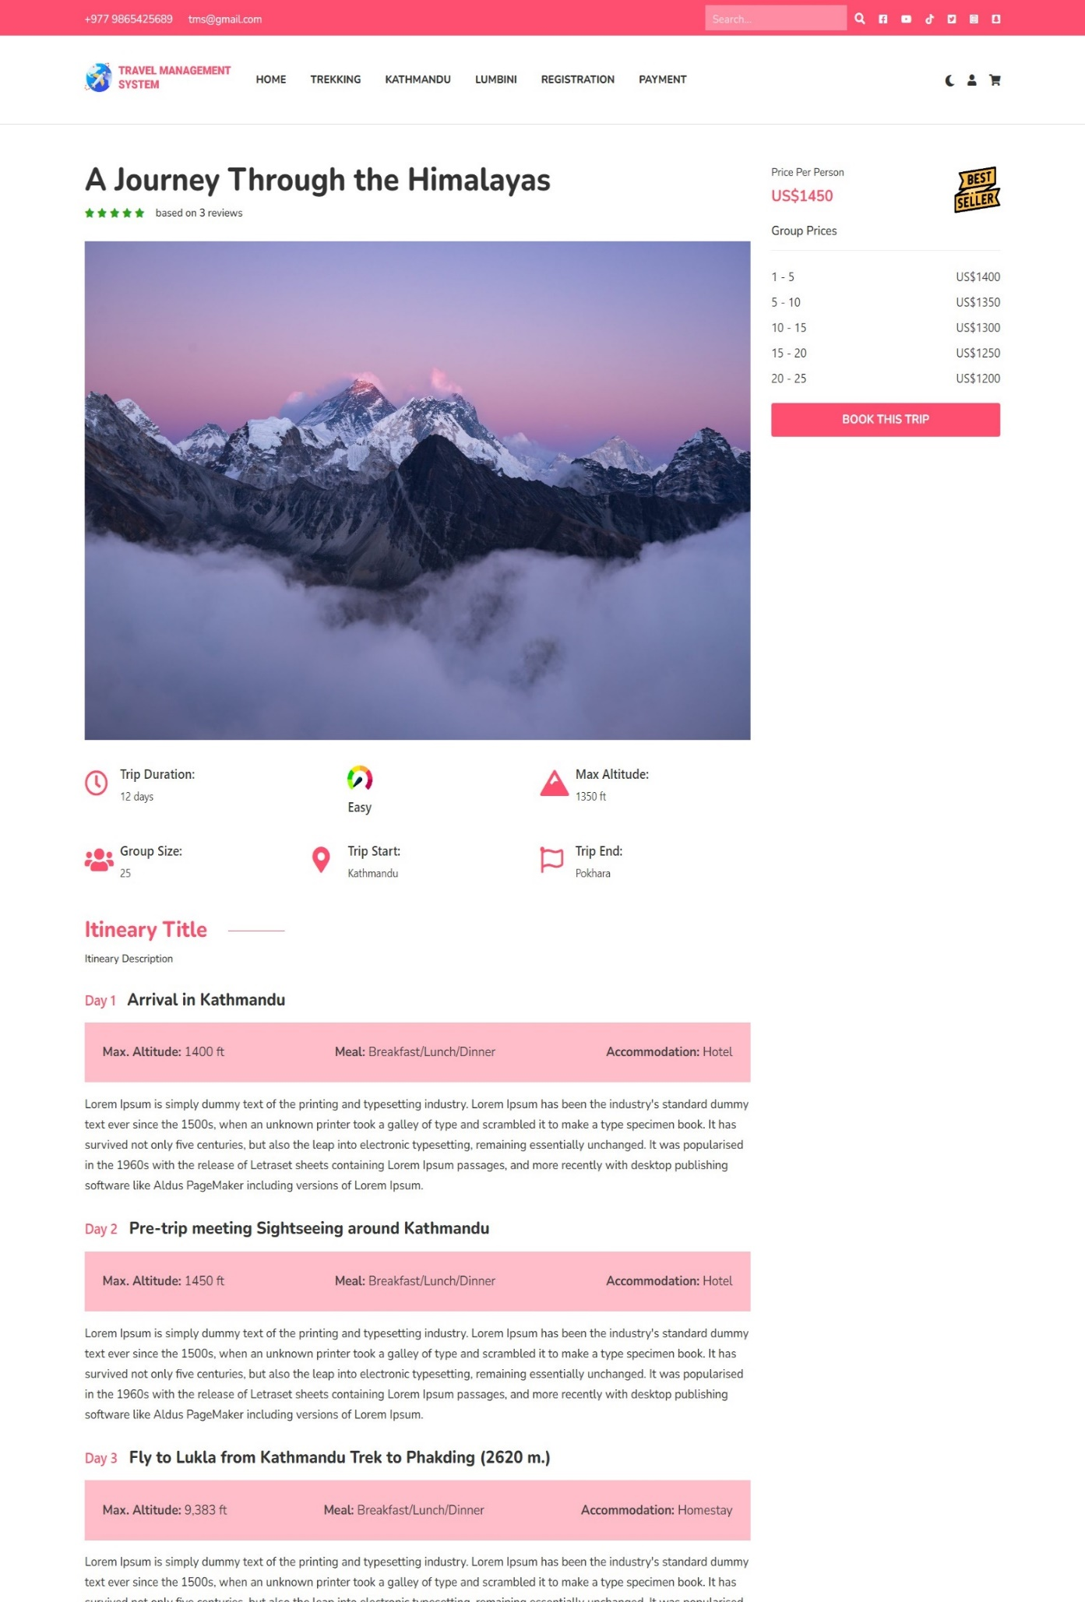

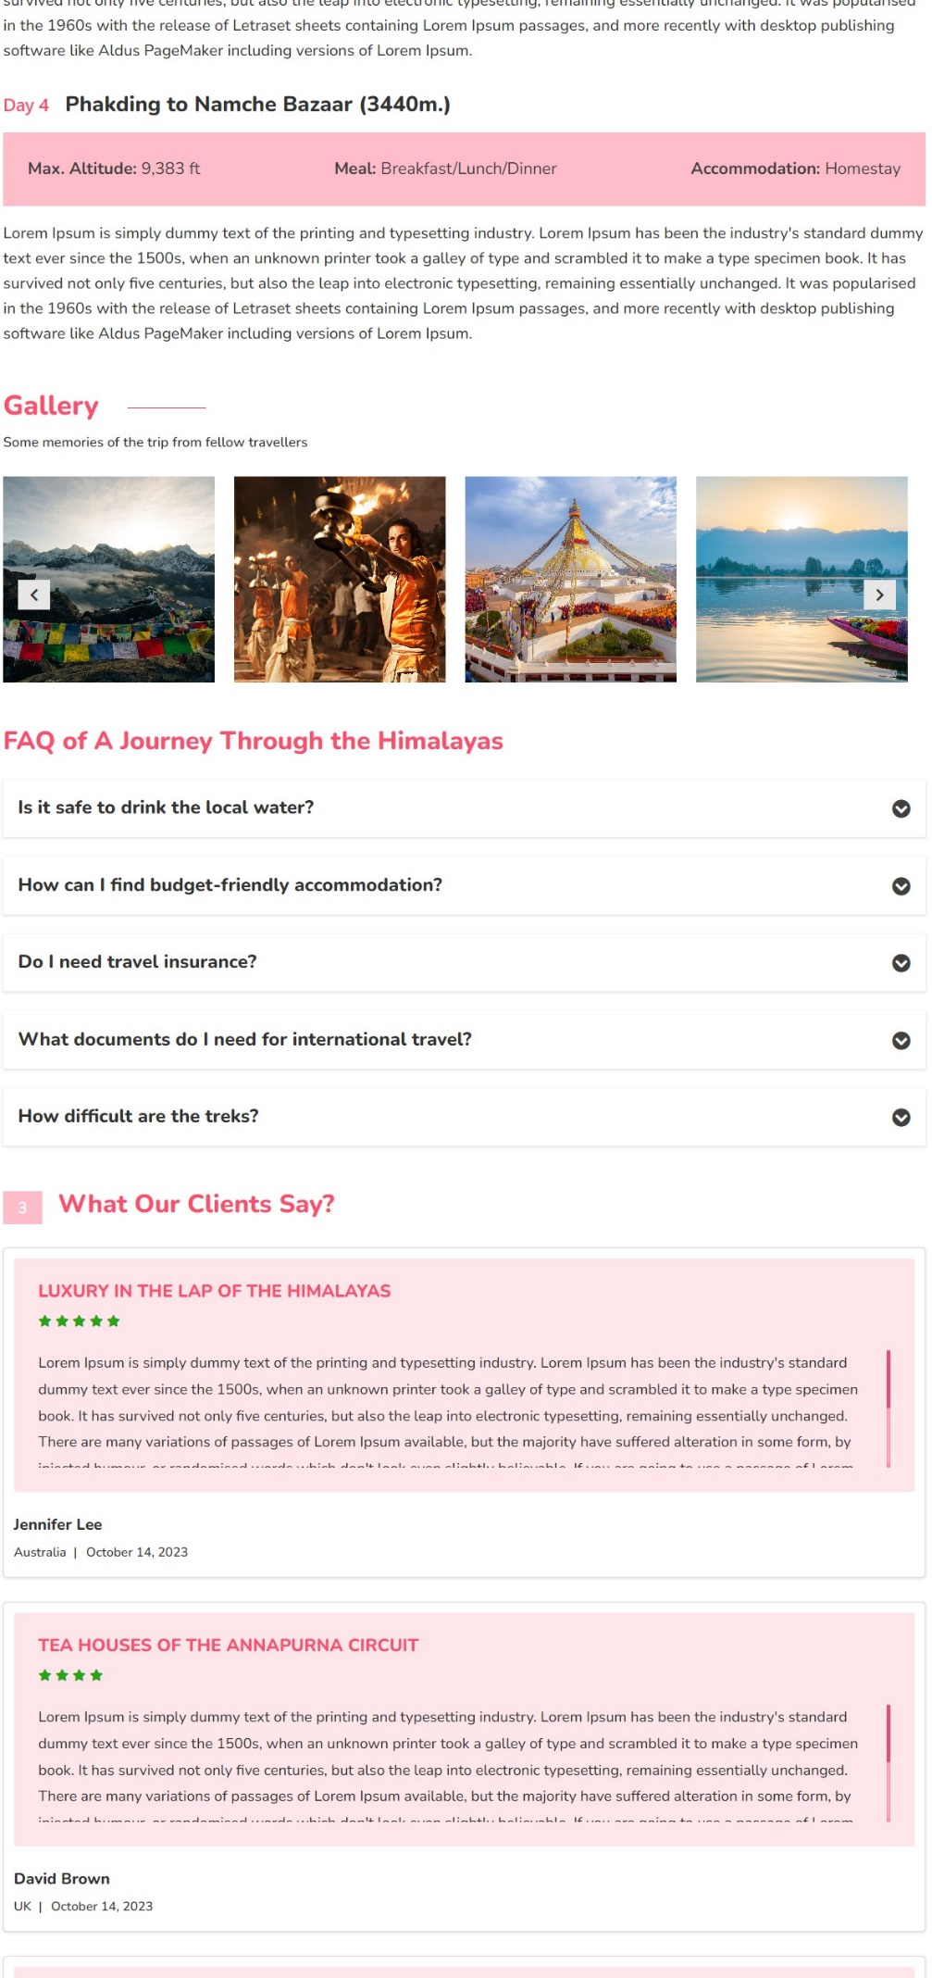

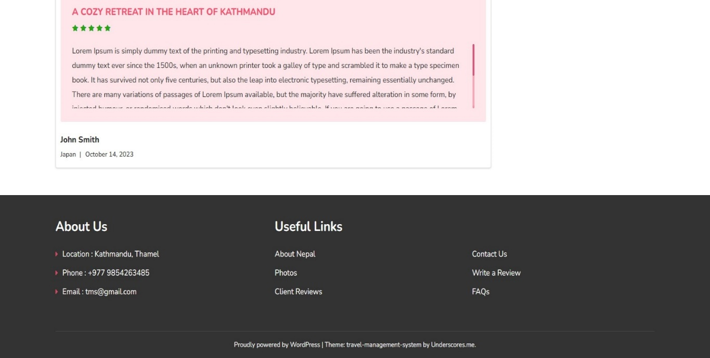

**Figure 15: Single**

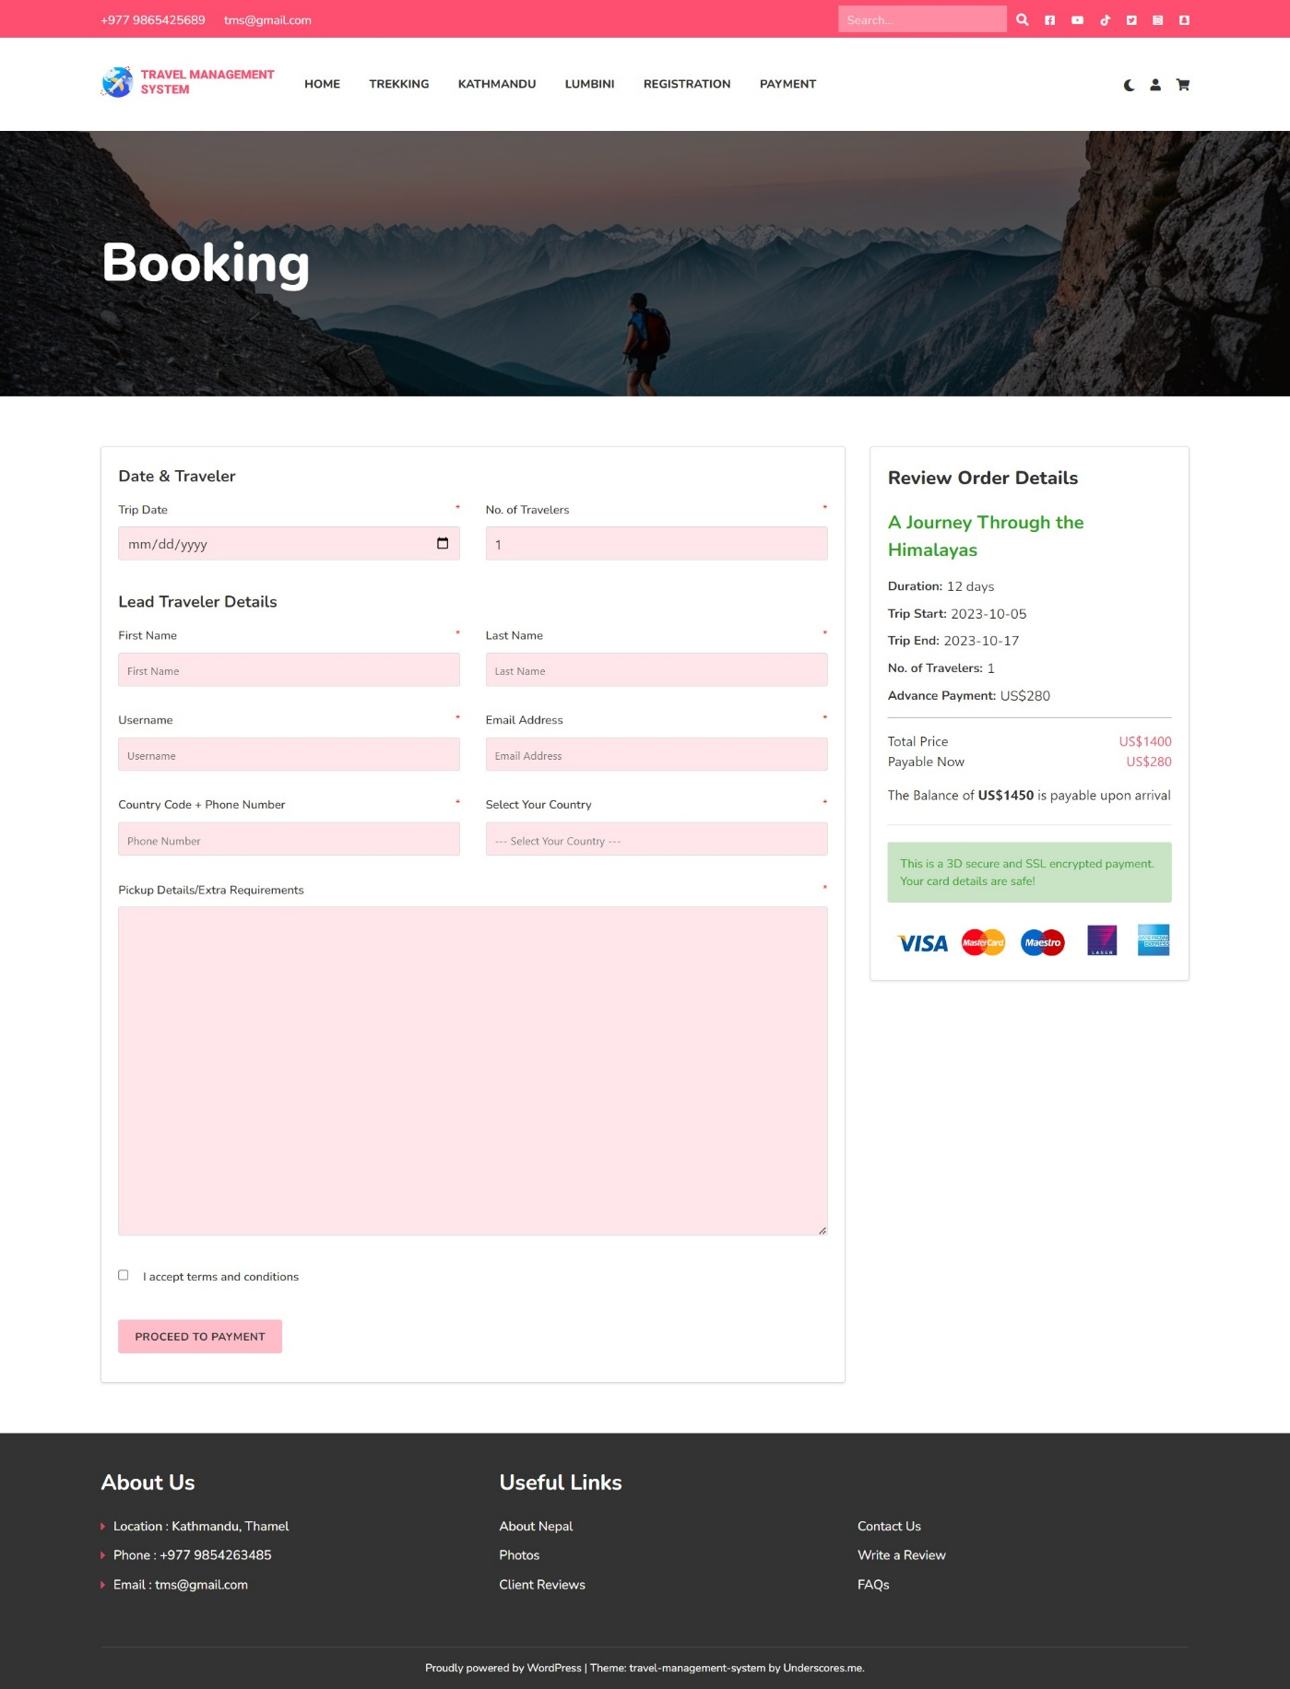

**Figure 16: Booking**

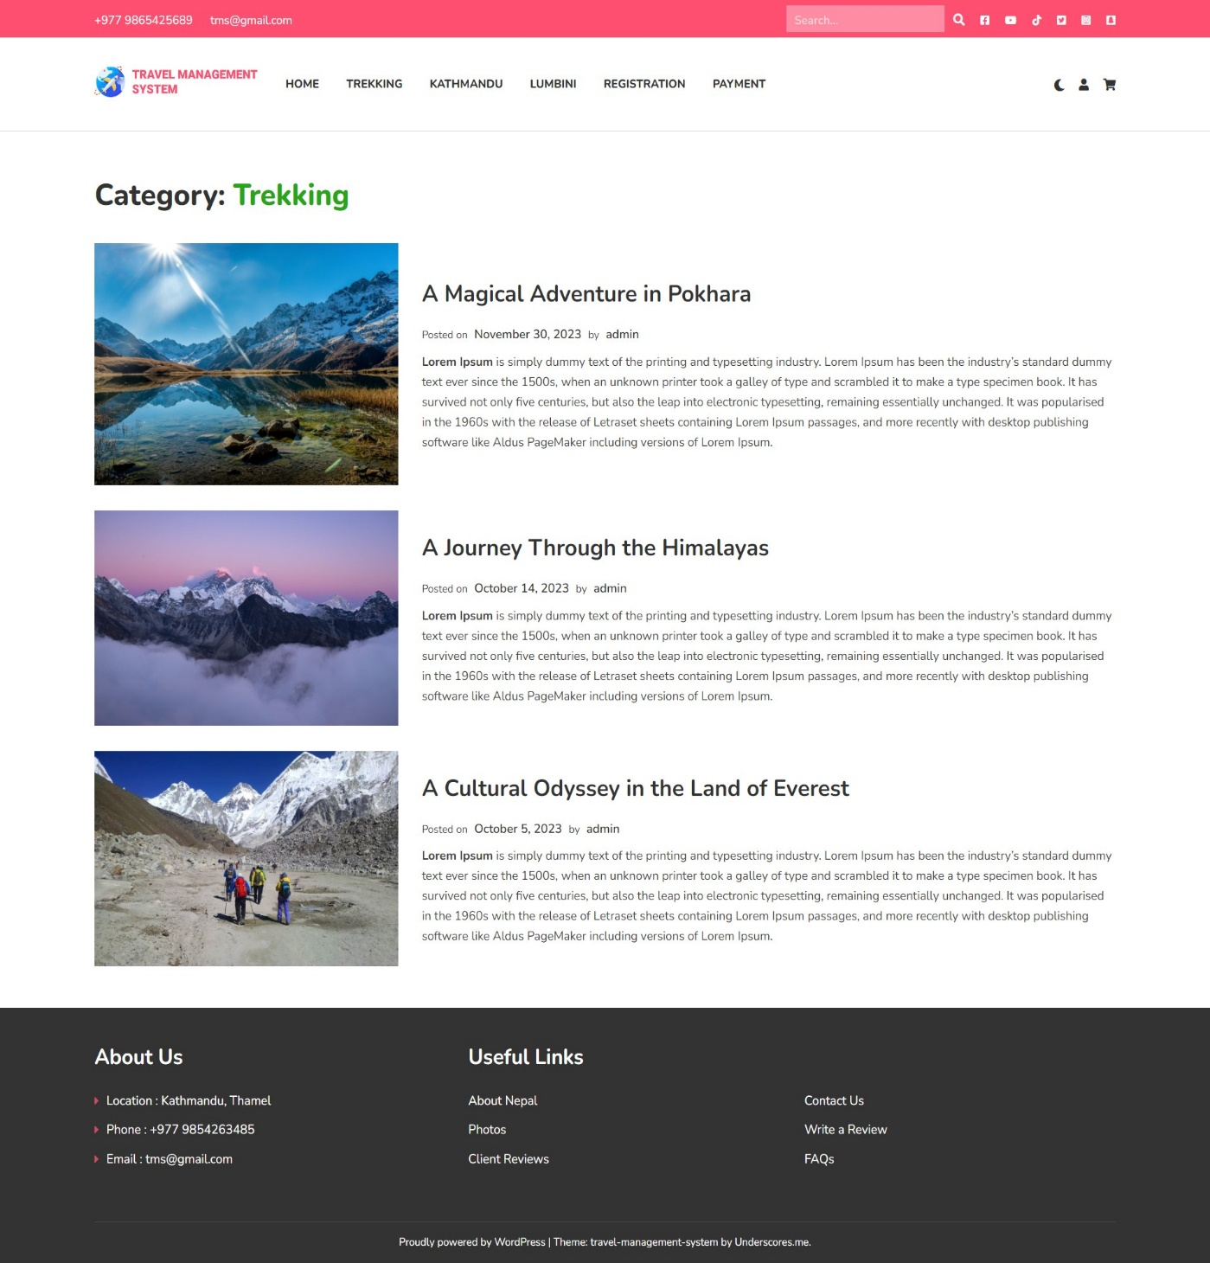

**Figure 17: Archive**

**Change log**

|  |  |
| --- | --- |
| **Date** | **Change** |
| 2023/11/24 | Table of content, figures, tables |
| 2023/12/2 | Indents, Grammar |
| 2023/12/3 | Er diagrams, DFD |
| 2023/12/4 | Test Cases |
| 2023/12/4 | References, Appendix |
| 2023/12/4 | Background study and literature review |
| 2023/12/6 | Page number |
| 2023/12/31 | Date |